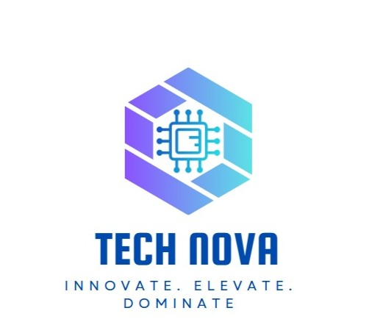

# Employee Engagement Template

# Employee Information

What is your job role?

Individual Contributor

Team Lead

Manager

Senior Manager

Regional Manager

Vice President

Management / C-Level

Partner

Owner

Volunteer

Intern

Other

What department do you work in?

Finance

IT

Human Resources

Operations

Testing

CRM

ERD

Customer Service

Did you feel a sense of belonging within the team and organization?

No. The environment lacks unity and openness.

How would you rate the work environment and culture?

Toxic. There's discrimination and a lack of collaboration.

How would you describe the effectiveness of your immediate supervisor?

Ineffective. The manager suppresses initiative and restricts employee roles.

Were your goals and expectations aligned with the organization’s vision?

Yes, but the environment did not allow any meaningful contribution.

Did you find the company’s policies and procedures fair and equitable?

No. Unclear promotion policy and gender-based hiring practices.

How would you rate the organization’s support for maintaining a healthy work-life balance?

Poor. No flexibility and unreasonable workload.

Were you satisfied with your salary and benefits package?

No. Salary is lower than market average and no additional benefits.

Did you receive enough training and development opportunities?

No. No development path or investment in skills.

Did you experience burnout or excessive stress in your role?

Yes. Lack of appreciation and excessive pressure.

Would you recommend this company as a good place to work?

No. The environment is unfair and unsupportive.

Do you find your daily tasks engaging and meaningful?

No. Tasks are repetitive and not growth-oriented.

Do you feel recognized for your contributions and efforts?

No. Efforts are overlooked, even when results are delivered.

Do you feel challenged in your role in a positive way?

No. My growth is hindered by team and management behavior.

How would you rate the overall work environment in the IT department?

Poor. The environment is **dominated by micromanagement, lack of collaboration, and minimal support** for innovation or development. Employees feel **undervalued, unheard, and overworked**, which leads to low morale and high disengagement.

How comfortable do you feel reaching out for help when facing technical challenges?

Not comfortable. The team environment is **not collaborative**, and the manager’s attitude discourages asking questions or sharing challenges. There’s a fear of being judged or ignored, so many issues go unresolved or are silently dealt with.

Have you received sufficient training and development opportunities in the last year?

No. There is a **clear lack of training and professional development.** Employees are expected to perform without being equipped with updated knowledge, tools, or learning opportunities, which affects both morale and performance.

How would you describe your current workload?

The workload is **intense and unstructured**. Tasks are assigned without proper planning, often piling up and leading to stress and pressure. There is no regard for employee capacity or well-being, which contributes to burnout.

What improvements would you suggest to enhance employee engagement and job satisfaction?

1- Implement a fair and transparent promotion policy with clear criteria.

2-Introduce regular training programs tailored to employee needs.

3-Encourage open communication and idea-sharing without fear of rejection.

Is leadership invested in and contributing to your culture initiatives?

No. Leadership is not actively involved in shaping or supporting a healthy team culture. Employee voices are ignored, and managers focus only on task completion rather than engagement or morale.

Do you see yourself working here in a year?

No. Without clear development opportunities, fair treatment, or recognition, there is little reason to stay long-term. The toxic atmosphere discourages retention.

Does your work challenge you and aid your development?

No. Tasks are repetitive and restrictive, offering little intellectual or professional growth. Development is further blocked by the manager’s controlling behavior.

Do you have the tools needed to maximize your potential here?

No. The **testing tools and systems are outdated,** and employees are not given the resources or authority to improve their work environment or results.

What motivates you to do your best work here?

The main motivation is personal integrity and a desire for excellence, but it’s not reinforced by the company. Internal motivation is often diminished by the lack of appreciation.

What could we do better to support your career growth and development?

1-Introduce regular technical training and upskilling.

2- Develop a clear and transparent promotion system.

3-Encourage open communication between employees and managers.

4- Update tools and systems to improve efficiency.

5- Foster a collaborative environment where ideas are valued.

6-Coach managers on emotional intelligence and fair leadership.